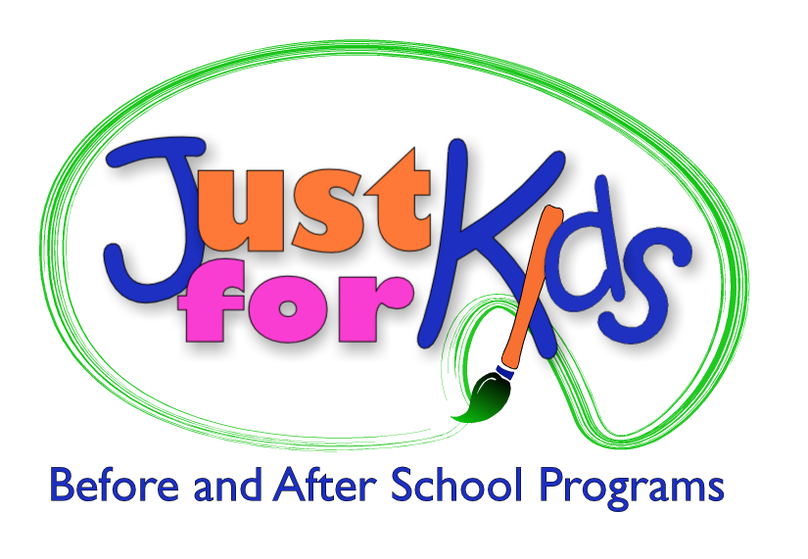
Administrative Internship
Just for Kids, a not-for-profit leader in the child care field, has an opportunity for an Administrative intern at our main office in Williamsville, NY. We manage year-round programs for local School Districts and select private schools, serving almost 1,000 local students and employing over 150 staff.
Our internship program will offer you hands-on experience in a fast paced environment that will also offer you course credit, if desired. Our team will provide you with an enriched internship experience in a variety of areas, spanning educational programming and curriculum development, business planning, budgeting, marketing, organization of special events, and a variety of large scale projects. The Administrative intern reports to the Executive Director, and also manages our Service Learning Program, and works with our Human Resources department to support talent management.
Hours are flexible to suit the needs of a college student, and average 10-15 per week, or per your college’s requirements for course credit (typically about 135 hours / semester).
The ideal candidate:
- Undergrad or graduate students looking to expand experience into the structural, administrative, and organizational realm of non-profit organizations
- Interest in the field of education, human services, or OST (Out of School Time) programming
Expectations:
- Ability to effectively balance multiple projects and meet deadlines
- Strong communication skills (written and verbal)
- Proficiency in Microsoft Office Suite
- Work well independently and as part of a team
- Possess a flexible, proactive attitude and an entrepreneurial spirit!
We are happy to provide documentation per college requirements for course credit.
Just for Kids is proud to have been awarded: Employer of the Year: 2012 Buffalo State College; 2015 University at Buffalo; Buffalo Business First: Employer of the Year Finalist, 2015; Child Care Provider of the Year, Child Care Resource Network (2015)
Please email your resume with a statement of interest to: HR@justforkidsonline.org
Just for Kids School Age Programs
6265 Sheridan Dr., Suite 106 Williamsville, NY 14221
www.justforkidsonline.org

