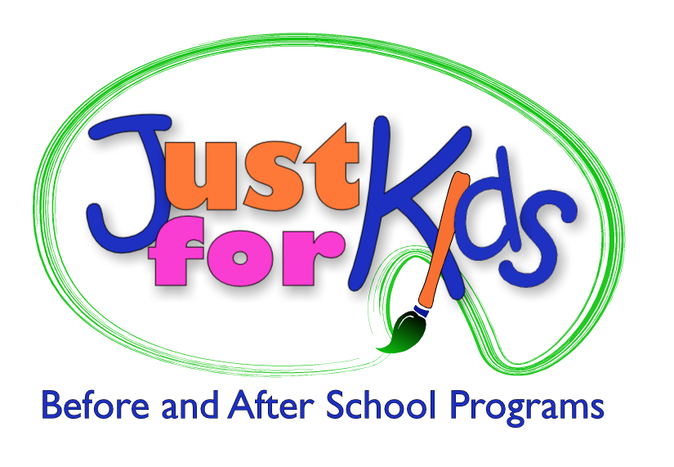
Human Resource Internship
Enjoy helping others succeed? Want to help your community?
TripleTrack, a leader in the Human Resource outsourcing, and its sister company Just for Kids Before & After School Programs, a non-profit leader in the child care field, have an opportunity for an unpaid part-time Human Resources Intern with our corporate office in Williamsville, NY. Our internship program will offer hands-on experience in a fast paced, ever changing environment. Our HR team will provide an enriched internship experience in recruiting, employee relations, benefits, and Employee Assistance Programs. We prefer interns who would be available for a minimum of 15 to 20 hours per week and we are willing to work with school schedules. Course credit can be offered.
Requirements:
- Currently in Junior or Senior year of college, majoring in Human Resources or Business field
- General knowledge of Human Resources practices and disciplines either through school or other internships
- The ability to effectively balance multiple projects and meet tight deadlines
- Strong communication skills and computer proficiency in Microsoft Office Suite
- The ability to work well with others and as part of a team
- The ability to follow direction, contribute openly, and have a flexible, proactive, can-do attitude
Please forward your resume with a letter detailing your days and hours of availability and reasons for interest in the internship position to: hr@justforkidsonline.org.

TripleTrackHR Partners
Just for Kids Before & After School Programs
6265 Sheridan Drive, Suite 106, Williamsville, NY 14221
www.tripletrackhrpartners.com
www.justforkidsonline.org

